# **Scenario 1:**

DECLARE

v_age NUMBER;

BEGIN

FOR cust IN (SELECT CustomerID, DOB FROM Customers) LOOP

v_age := FLOOR(MONTHS_BETWEEN(SYSDATE, cust.DOB) / 12);

IF v_age > 60 THEN

UPDATE Loans

SET InterestRate = InterestRate – 1

WHERE CustomerID = cust.CustomerID;

END IF;

END LOOP;

COMMIT;

END;

/

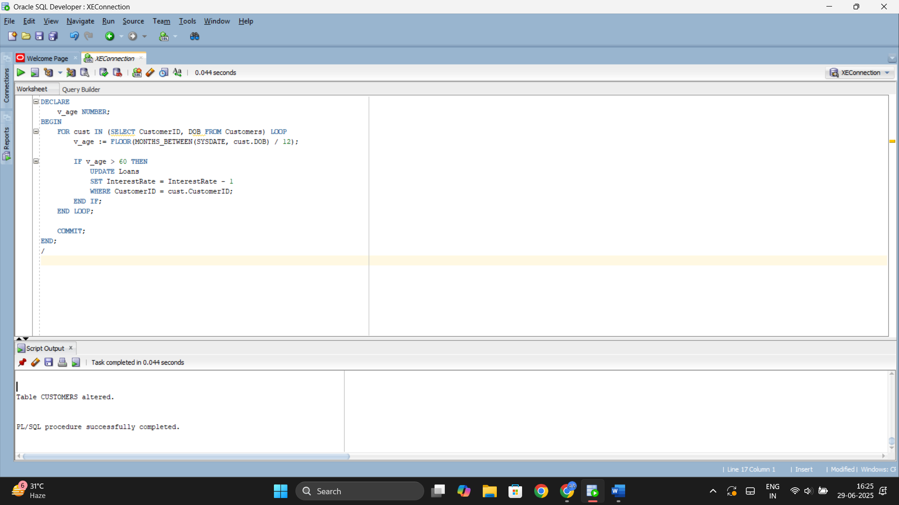

# **Scenario 2:**

BEGIN

FOR cust IN (SELECT CustomerID, Balance FROM Customers) LOOP

IF cust.Balance > 10000 THEN

UPDATE Customers

SET IsVIP = 'TRUE'

WHERE CustomerID = cust.CustomerID;

END IF;

END LOOP;

COMMIT;

END;

/

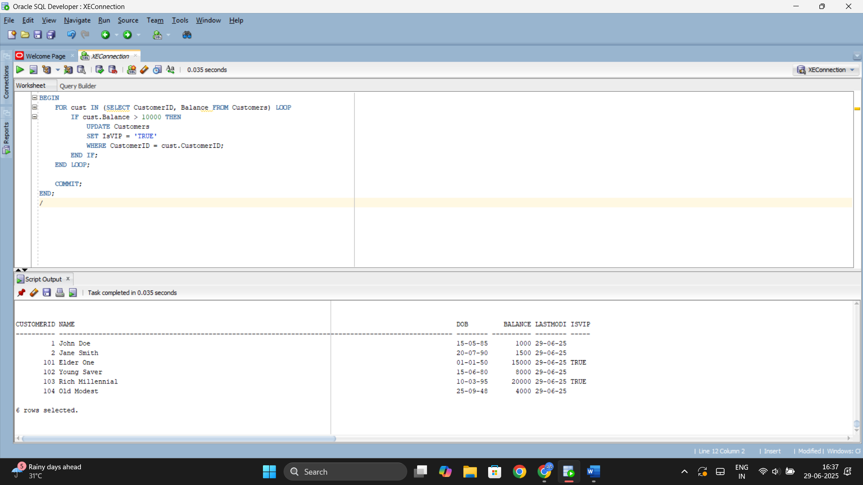

# **Scenario 3:**

SET SERVEROUTPUT ON;

DECLARE

v_name VARCHAR2(100);

BEGIN

FOR loan IN (

SELECT l.LoanID, l.CustomerID, l.EndDate, c.Name

FROM Loans l

JOIN Customers c ON l.CustomerID = c.CustomerID

WHERE l.EndDate BETWEEN SYSDATE AND SYSDATE + 30

) LOOP

DBMS_OUTPUT.PUT_LINE('Reminder: Loan ID ' || loan.LoanID ||

' for customer ' || loan.Name ||

' is due on ' || TO_CHAR(loan.EndDate, 'DD-Mon-YYYY'));

END LOOP;

END;

/

